Part 1: INTRODUCTION
- App introduction
- To manage quickly and save time, a coffee shop management application was born.
- The application helps users to manage the cafe easily, saving effort and time.
- Use object
- staff and management (branch).
- Staff function
  - Order food and drinks for guests.
  - Enter the payment form and print the payment order.
  - Enter the product into the warehouse.
  - End of shift
- Management function
  - Employee manager.
  - Warehouse management.
  - Sales Manager.
  - Bill management.
  - Customer management.

Part 2: INSTALLATON INSTRUCTION

      - Hardware Requirements
_ A minium computer system that will help you access all the tools in
_ 64 Megabytes of RAM or better
      - Software Requirements
_ NetBeanIDE.
_SQL Server.
_JDK 16.0.2.

Part 3: DATABASE
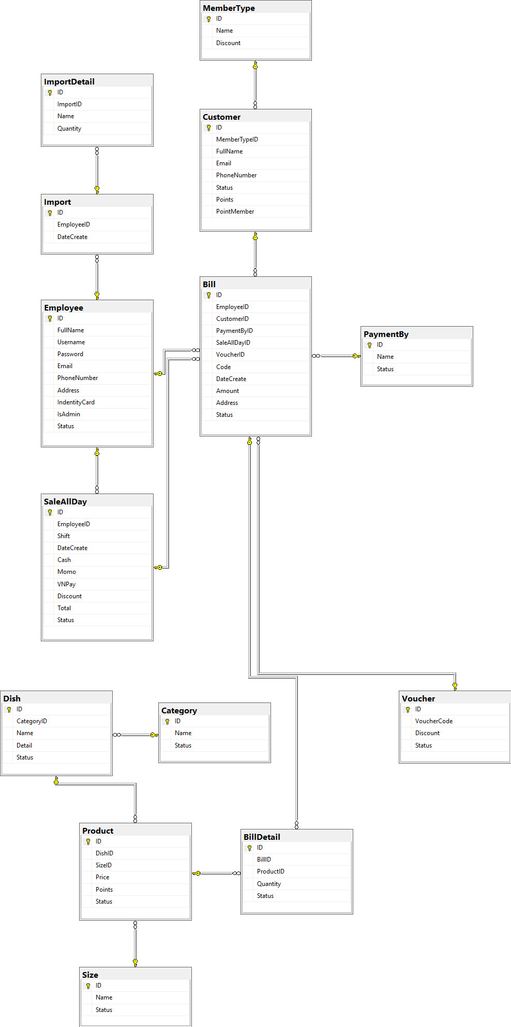
Part 4: USER MANUAL

I. Login interface
This is the first step to enter the system, the user will enter the username and password.
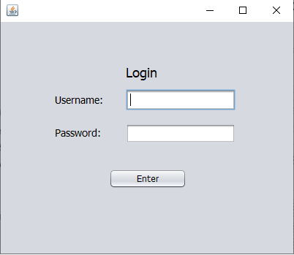
- Functional interface
Depending on the usage rights of each user (Admin, employee) the software and the system display the corresponding interface.
1. Admin interface
The user logs in as the highest authority (Admin), then the system will display the management interface for admin.
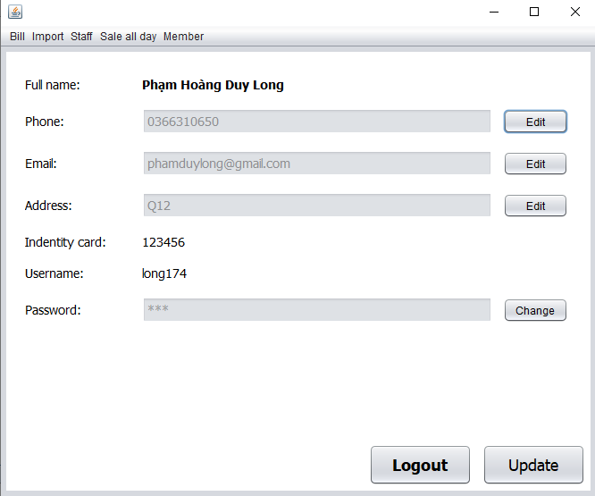
The main interface has the following sections: menu bar, admin information, update and edit information, logout.
  - Update information & logout
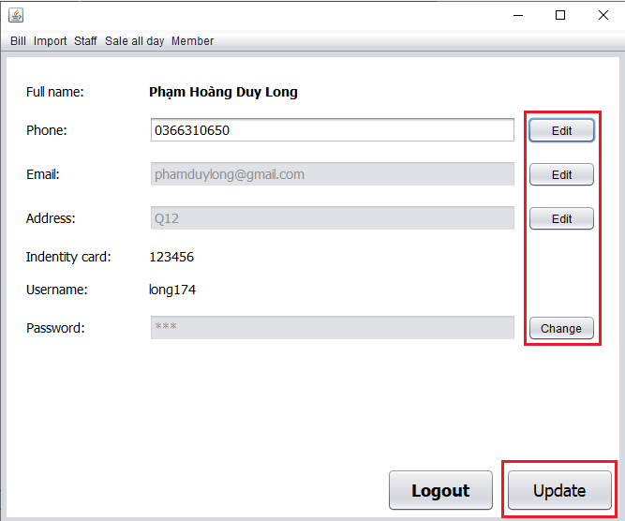
The user can edit the information by clicking on the edit button, then the information box will open to allow the user to enter, after entering, press the update button to save it.
User can choose logout to return to the login interface.

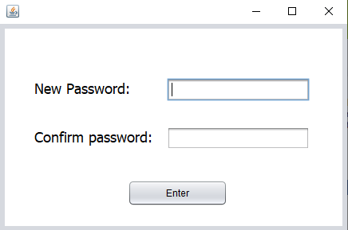
Users can also change the password via the change button, when pressing change will appear a form to change the password, after entering the new password press the enter button to complete and return to the main interface.
  - Menu bar
Functions on the menu bar: bill, import, staff, sale all day, member.
Bill
The bill function helps users manage the list of paid bills(Bill active), canceled bills(Bill negative).
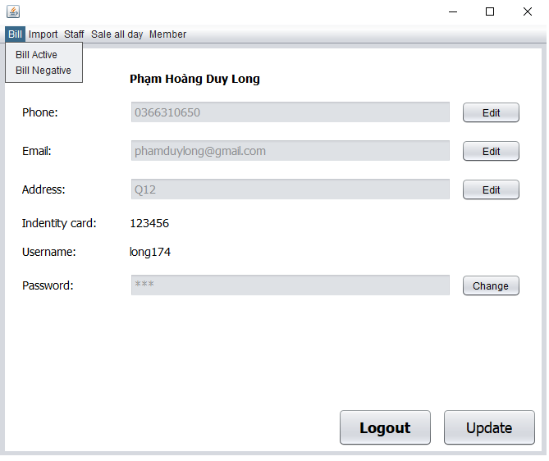
If the user chooses bill active, an interface will appear as shown below.
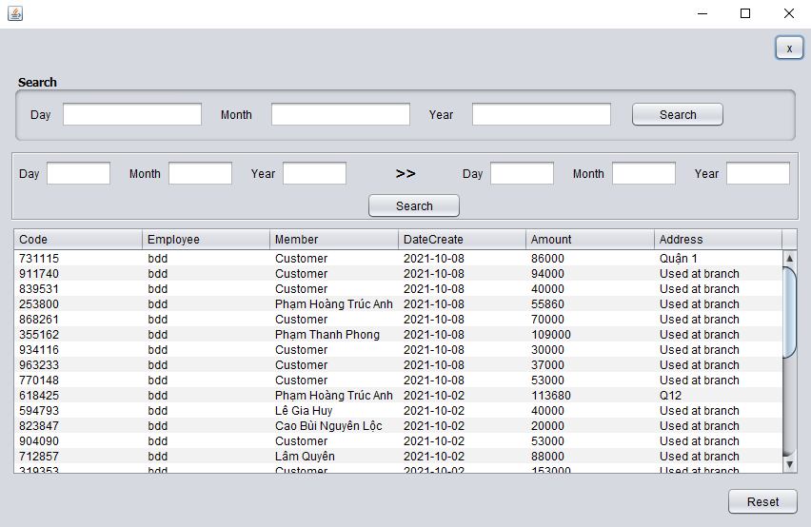
The top search box helps users search by date, the user will enter the date and then press the search button to search.
The search box below helps users search from any date to any day, and also enter all the information and press the search button to find it.
The reset button below is used to reload the data in the table.
The table below will show all the invoices that have been paid, and the user can click on an invoice in the table the system will show the user the details of that bill.
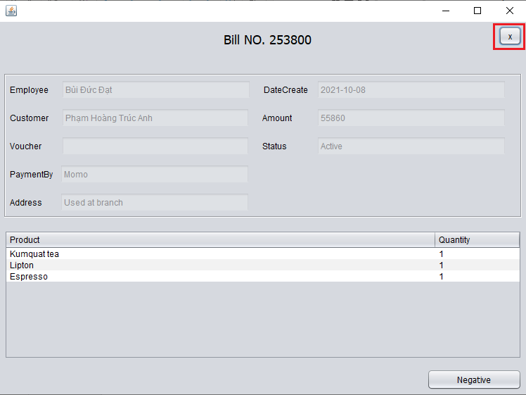

This interface will display the bill details and the user can cancel that bill by clicking the negative button below after pressing the button the system will turn off the bill detail interface and return to the active bill, in addition the user can Exit the bill details interface by clicking the x button on the upper right.
And the user will also press the x button on the upper right of the bill active interface to exit and return to the original main interface.

And users can also view canceled invoices when selecting bill negative.
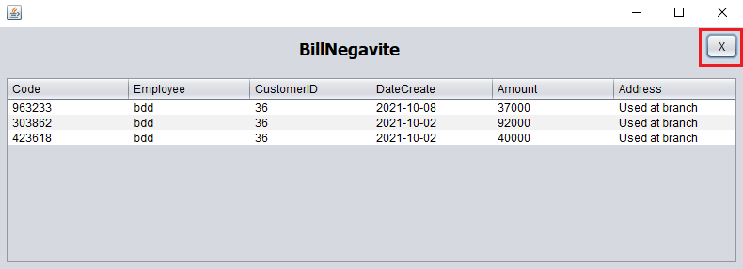
The user will also press the x button on the upper right to exit.

Import function helps to manage employee's import.
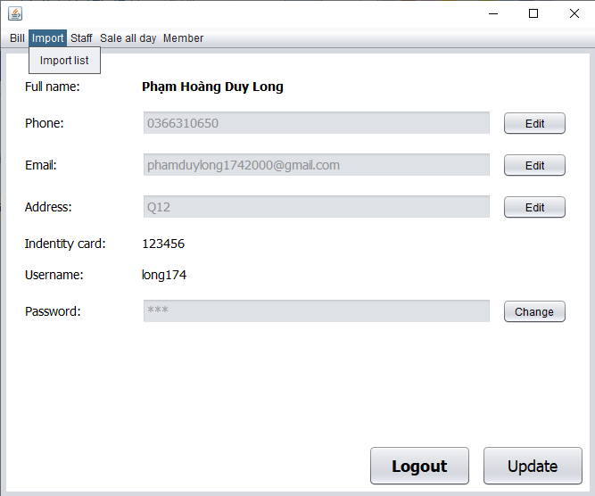
The user selects import list, the system will display the interface as shown below.

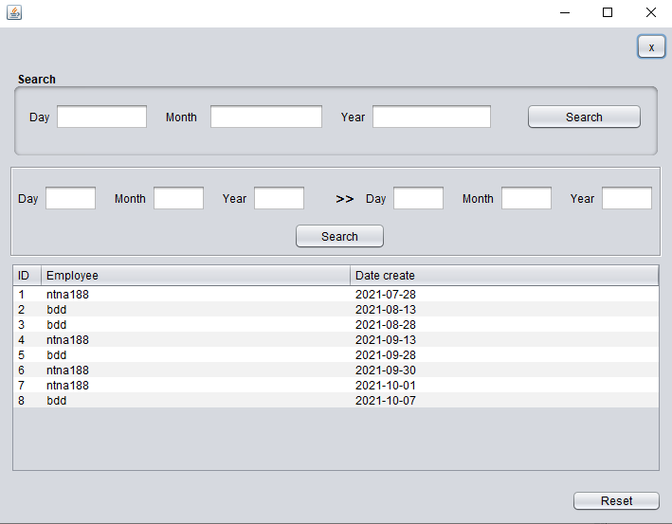
The user will also press the x button on the upper right to exit.
The reset button below is used to reload the data in the table.
The top search box helps users search by date, the user will enter the date and then press the search button to search.
The search box below helps users search from any date to any day, and also enter all the information and press the search button to find it.
Table will show the employees entered and the date entered into the warehouse. When clicking on an employee in the table, the system will display details of the employee's name, date and date of entering the entered product and quantity.
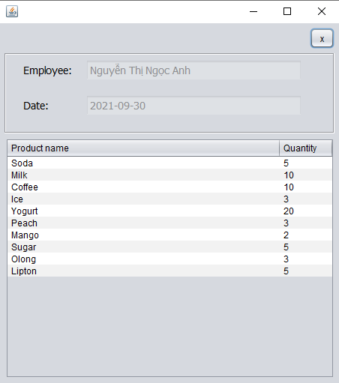
The user will also press the x button on the upper right to exit.
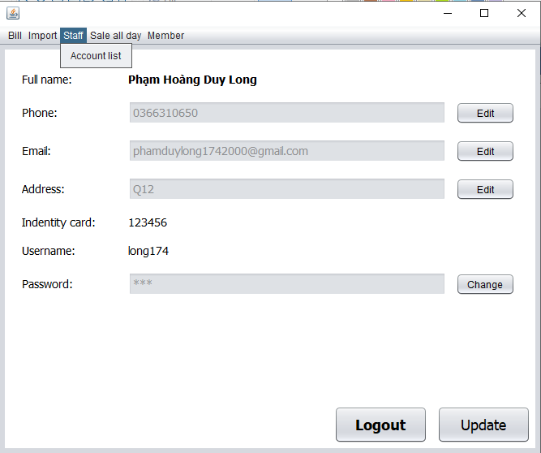
Staff function helps users manage the list of employees.
When the user selects the account list, the system will display the employee list interface.
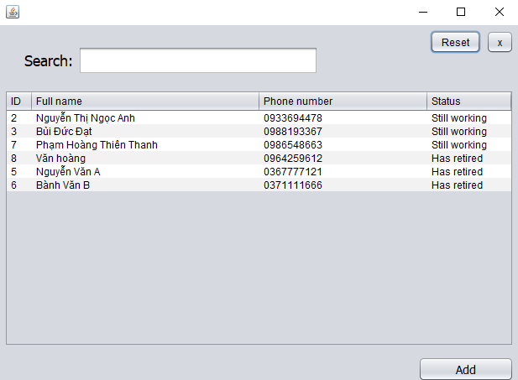
The user will press the x button next to the reset button to exit, and press the reset button to reload the data in the table.
Search box helps users to search by letters and numbers.
Table will display a list of employees and when the user clicks on an employee in the table, the system will display details and edit some employee information.
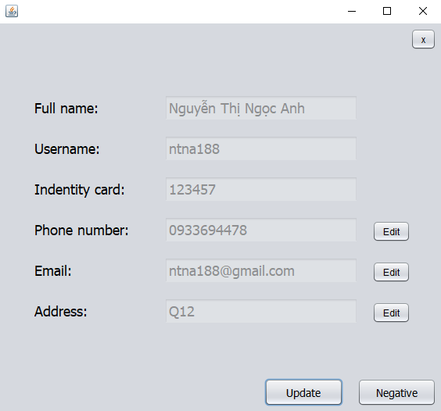
The user will also press the x button on the upper right to exit.
To edit, the user will press the edit button to edit, after editing, press the update button to save.
User can fire employee by clicking negative button after pressing this button it will no longer work. The employees who have quit their jobs, Employees who have quit their jobs, the status column in the table of the account list interface will display as has retired, and when clicking on retired employees, the negative button will not work.
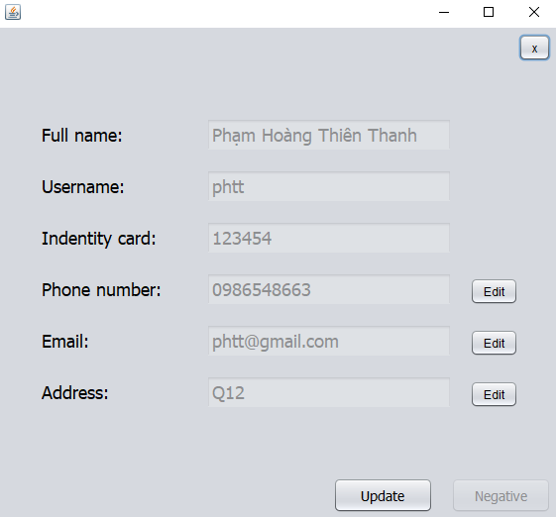

The add button in the account list interface is used to add new employees, and when pressing the add button, the system will display the interface to enter employee information.

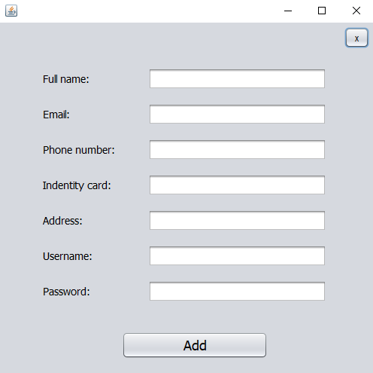

The user will also press the x button on the upper right to exit.
Press the add button to add after entering all the information.

All day sale function helps to manage sales of employees.
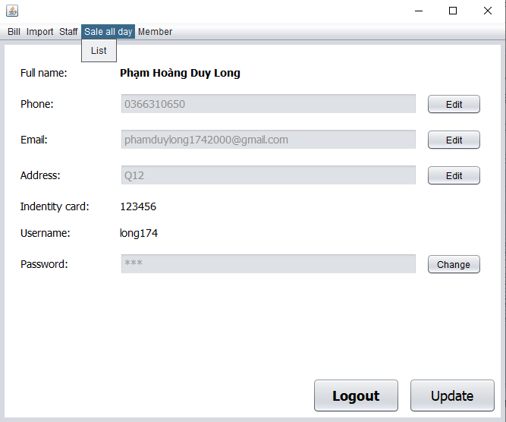
The user selects the list, the system will display the interface as shown below.
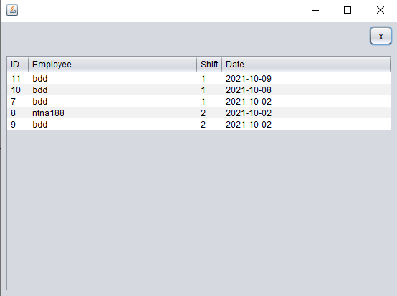
The user will also press the x button on the upper right to exit.
A table that will show the employee's shift and the employee's working day, and clicking on an employee in the system panel will display a more detailed interface.
This interface will show the employee's total amount sold and purchased by this employee.
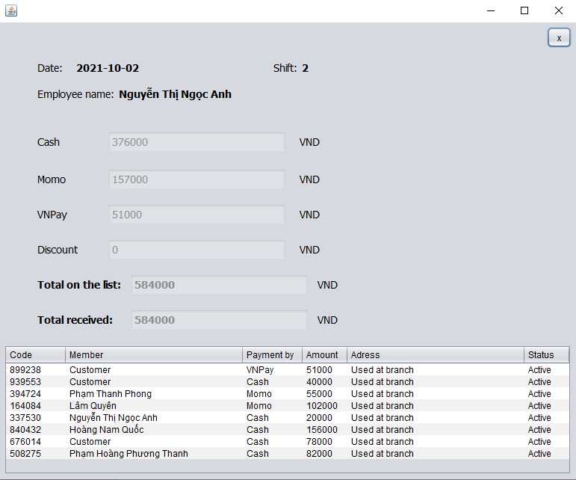

The user will also press the x button on the upper right to exit.

Member function helps users manage customer list (member list).
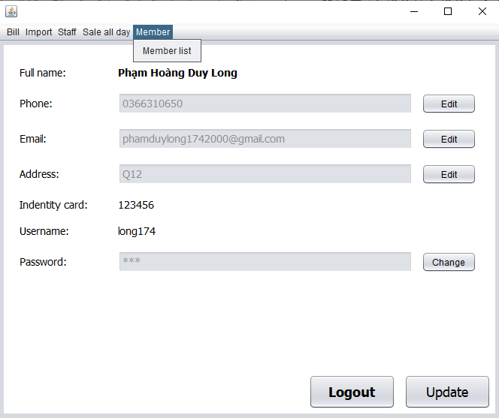

The user selects the member list, the system will display an interface as shown below.

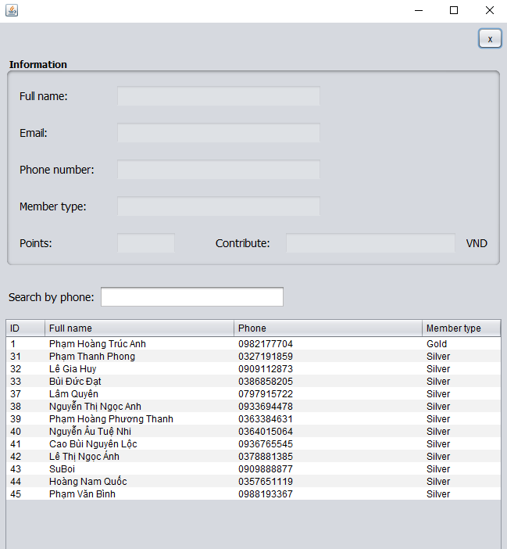
The user will also press the x button on the upper right to exit.
The search box helps users find customers through phone numbers by entering phone numbers. The table below will display customers with the same phone number as the person entered.
Table will display a list of customers, and when the user clicks on a customer, that customer information will be displayed on the information frame above.

2. Employee interface.
The user logs in under the lower authority (employee), then the system will display sales manager sales.

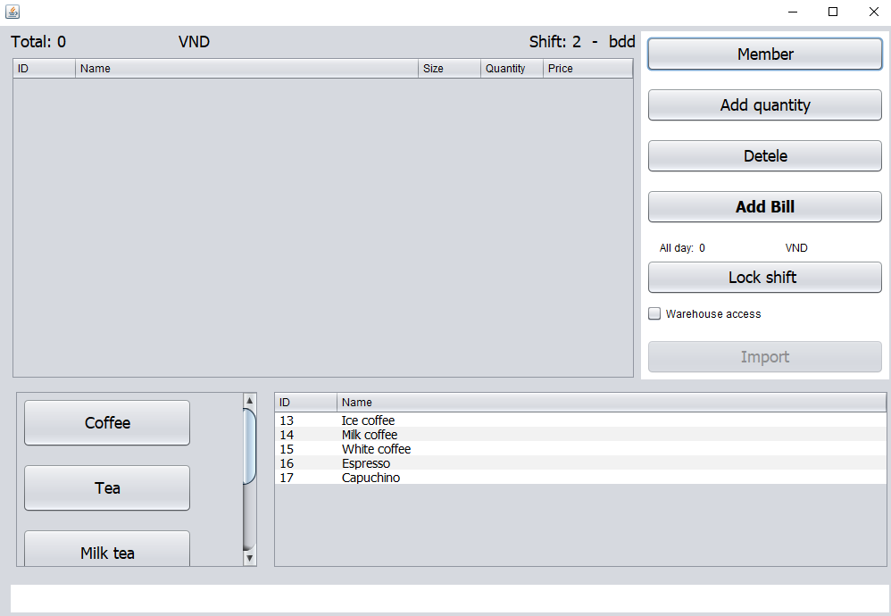

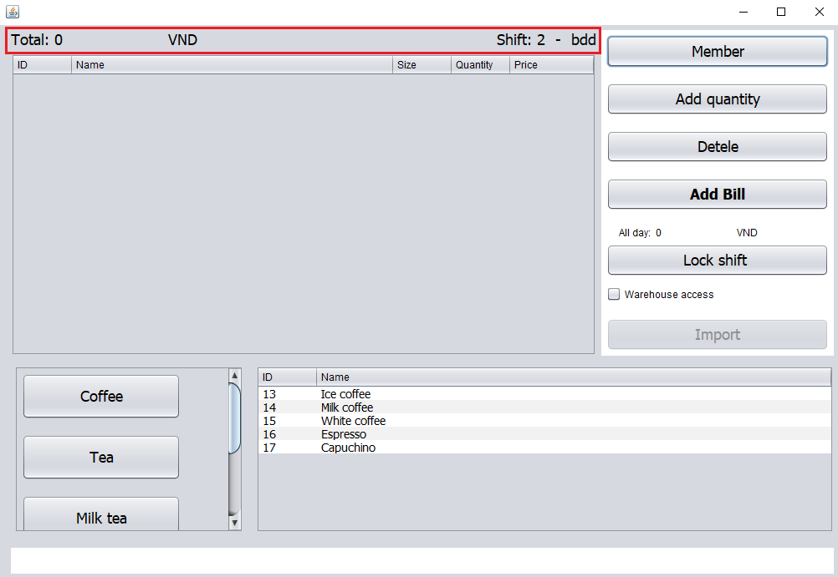
The top will display the total amount of product order, customer and employee's shift, and employee account name
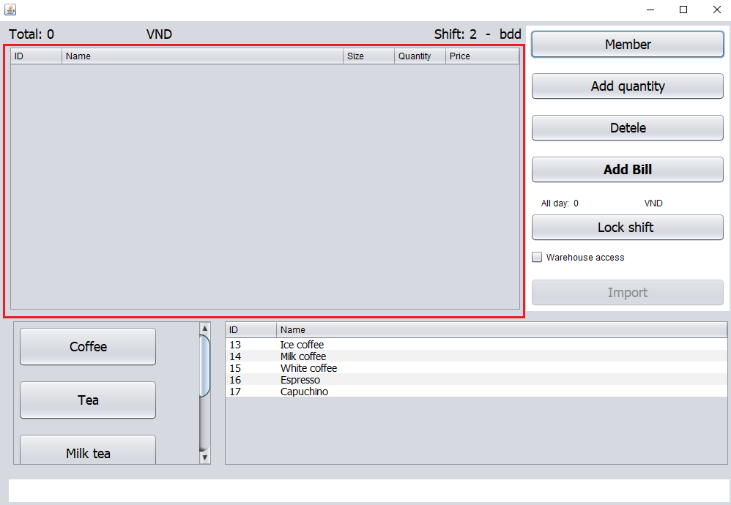
Below will be a table to display the ordered items including name, quantity and price.

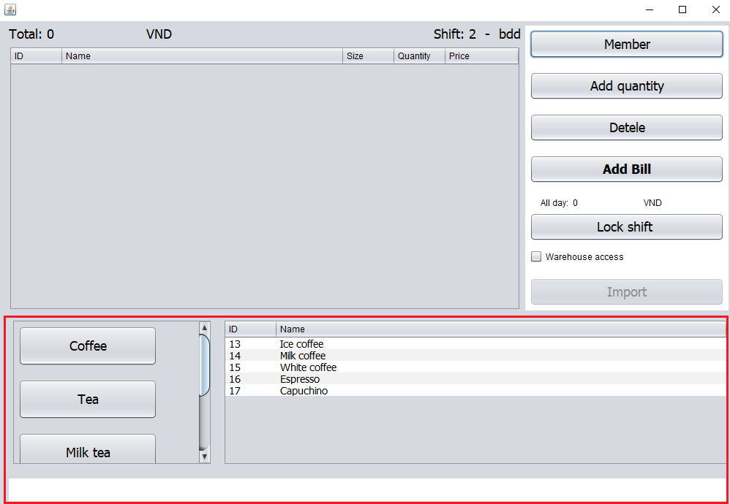
The bottom will display the hero buttons corresponding to the types of water or dishes, when clicked, will display a list of products of that type of water or dish in the next table. and when clicking on one of the products in the next table to order that dish, and the system will let that user choose the product size after choosing, the system will display it on the order table above.

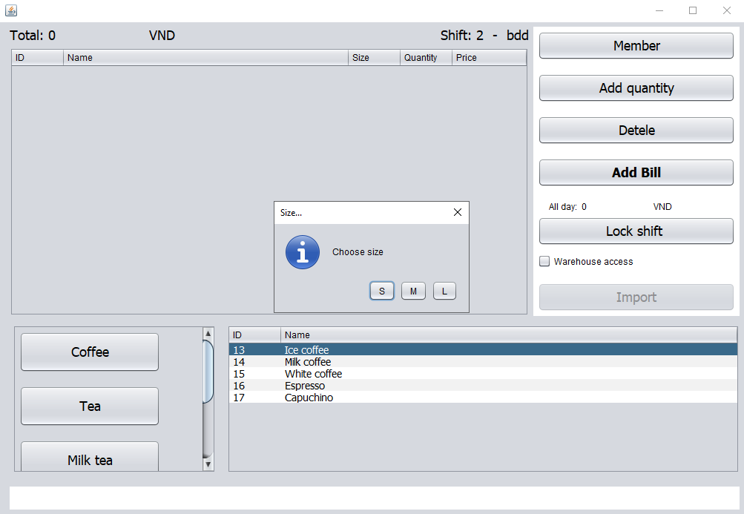

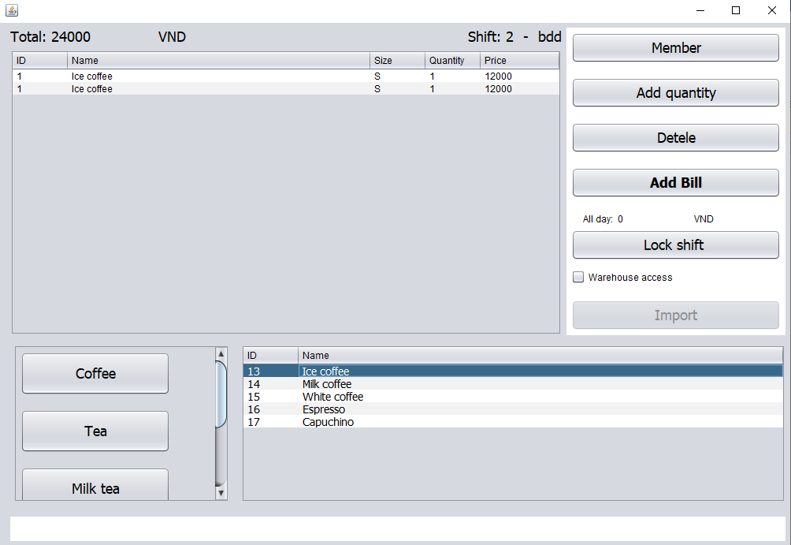
To add the number of users will click on the product in the order table then press the add quantity button to add the number of products press the delete button to delete, press add bill to pay.
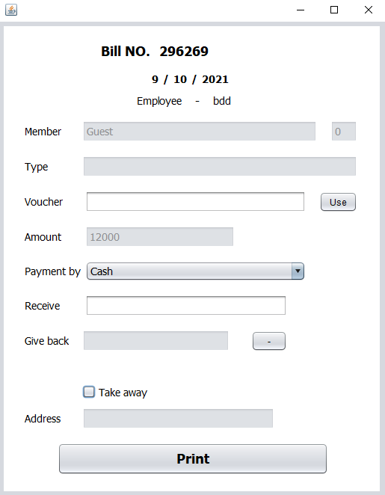
After pressing add bill to pay, the system will display an interface as shown above, the staff will enter all information and press the print button to print the bill, this is an order for customers who are not in the list of members of the company. The shop and the member box in the default bill interface are guest.
To order for a member of the shop's member list, one more step is needed to click the member button above the add quantity button, then the system will display an interface as shown below.
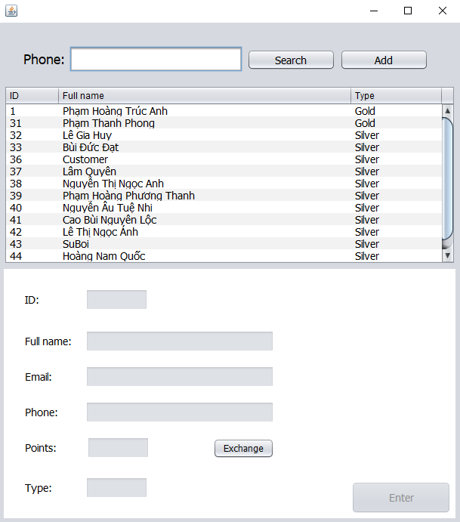

When that interface appears, the employee will click to select the member in the table who wants to order food and drink and then press enter, the system will return to the sales interface and the staff will order food for the customer as in the above steps.

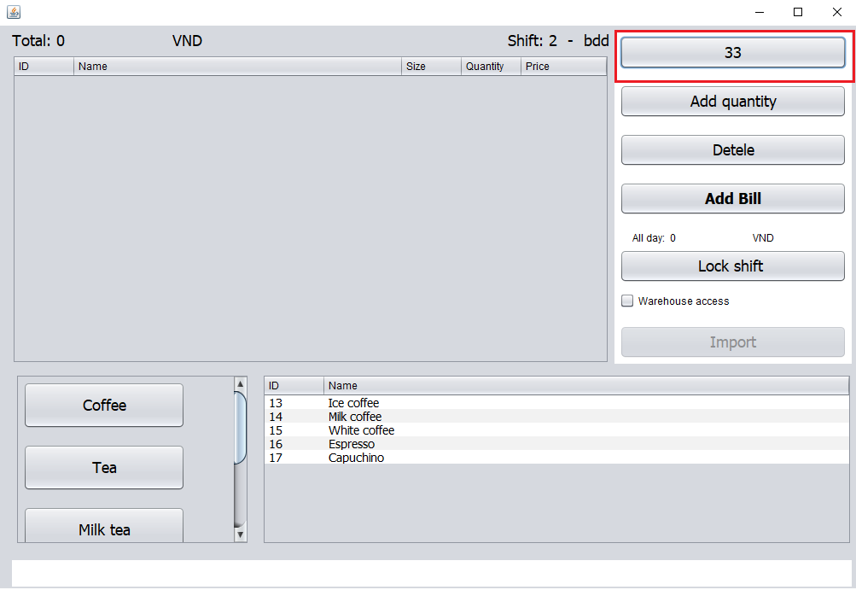
When paying, the member box will display the member's name in the add bill interface
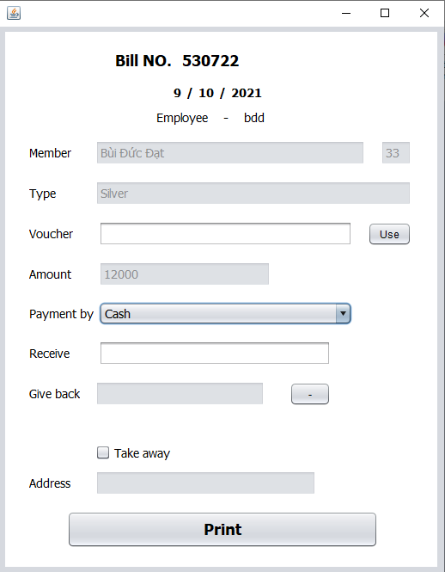

In addition, when clicking on a member in the table, the system will display the member information below.
Anyone who is a member in the shop when buying multiple systems will accumulate points and upgrade member, and can exchange points for water and food in the shop, to exchange points the staff will press the exchange button to exchange.
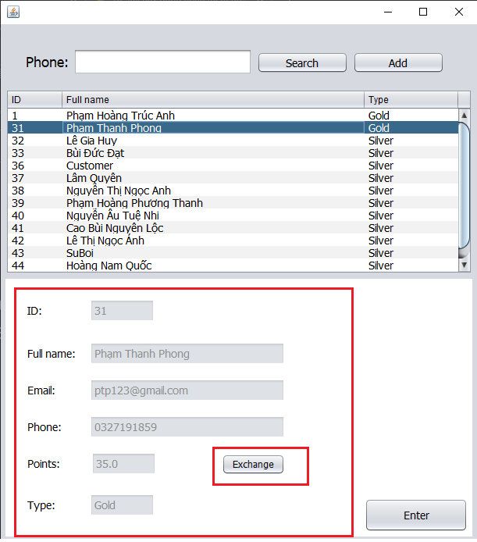
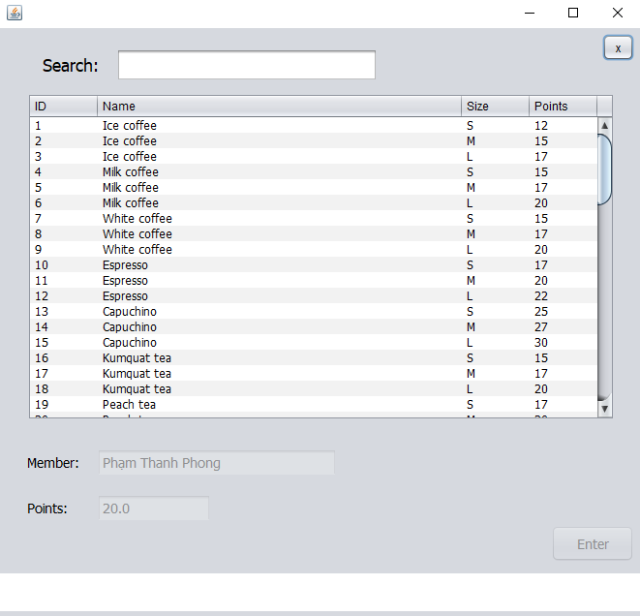
Search dialog can use product search.
The user will also press the x button on the upper right to exit.
Each product will have a number of points that can be exchanged if there are enough points, so that the staff will click on a product the customer changes and then press enter, and the system will return to the member interface, the staff will press the enter button Again to return to the order, at this time, the customer who has just redeemed the points will buy the item and exchange it for free.
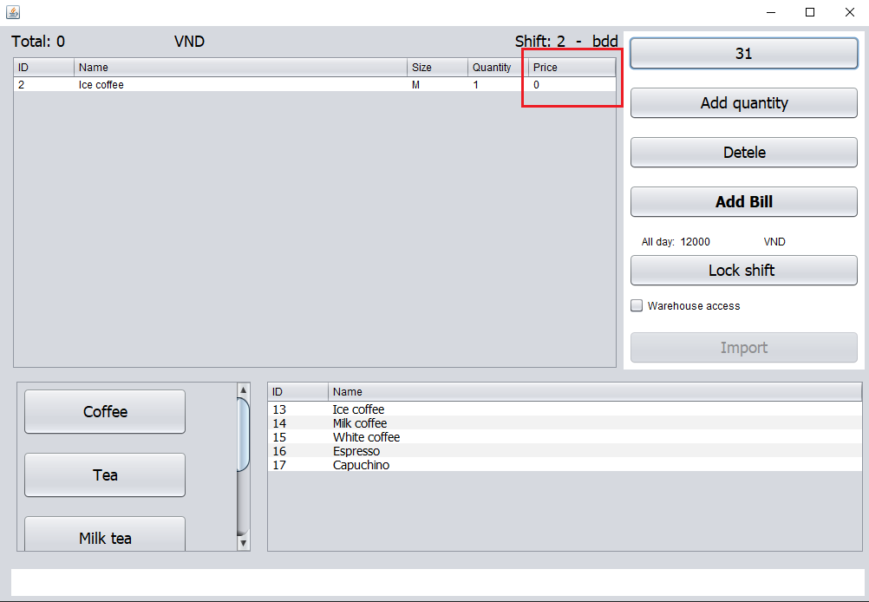
And employees can also search for members by entering information in the search box in the member interface and then pressing the search button. The search box can only enter phone numbers.
To add a new member, press the add button next to the search button, then enter all the information below and press the enter button to add a new one.
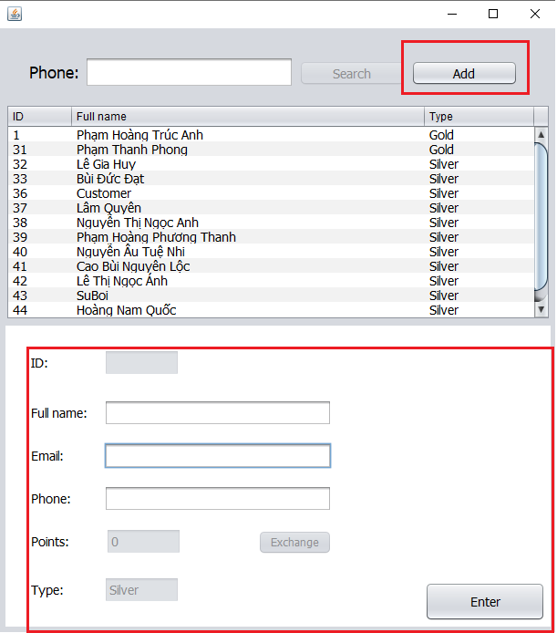
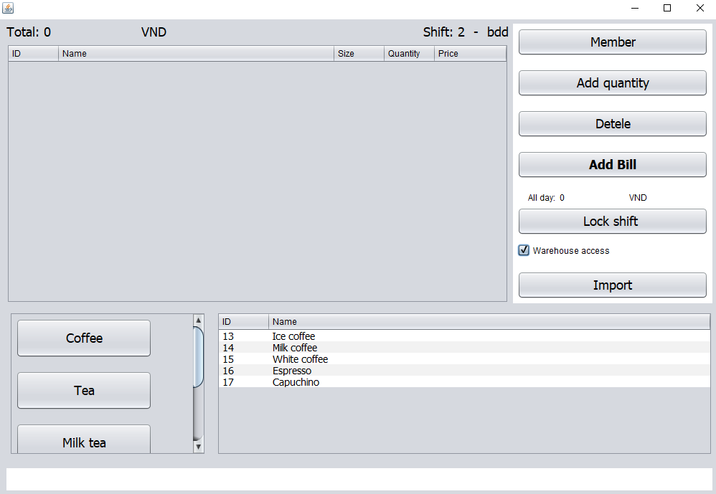
Employees can import more products into the warehouse by ticking the warehouse acces box and then pressing the import button, the interface to import will appear.
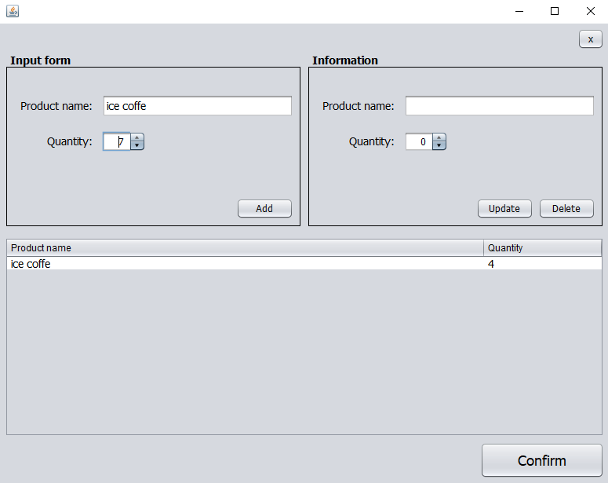
The employee presses the x button on the upper right to exit and return to the sales interface.
The employee enters the product in the product box in the left pane and adjusts the salary, then presses the add button to add the product that will be displayed in the table below.
And staff can click on the products entered in the product table, it will pop up in the right pane, now the staff can edit the product name and quantity then press the update button to save and the employee can also press delete button to delete the product you just imported.
When the employee has finished entering the product, he will press the confirm button below to save it in the warehouse and complete the import.
The all day line above the lock shift button will show the total amount the employee sold during the shift.
When the employee ends the shift, he will press the lock shift button to end his shift. When pressing the button, an interface will appear as shown below.
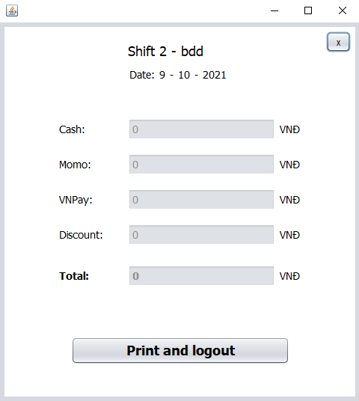
The employee presses the x button on the upper right to exit and return to the sales interface.
The employee presses the print and logout button to end the shift and the system will return to the login interface.
Part 5: DISTRIBUTION TABLE
 | Detail | Start |  | End |  | Member |  | Status
Build MODELS | Idea | 13/09 |  | 13/09 |  | Long |  | Done
Build MODELS | Build Database | 13/09 |  | 13/09 |  | Long |  | Done
Build MODELS | Check and confirm the database | 13/09 |  | 14/09 |  | Long |  | Done
Build MODELS | Build models | 15/09 |  | 15/09 |  | Long |  | Done
Views | Idea | 15/09 |  | 15/09 |  | Long |  | Done
Views | Build view | 15/09 |  | 15/09 |  | Long |  | Done
Controllers | Idea | 16/09 |  | 16/09 |  | Long |  | Done
Login (View + Controller) | Idea | 16/09 |  | 16/09 |  | Long |  | Done
Login (View + Controller) | Classification Account (Staff and Management) | 16/09 |  | 16/09 |  | Long |  | Done
Detail Controller | Controller of Sale form | 17/09 |  | 18/09 |  | Long |  | Done
Detail Controller | Controller of Member form | 17/09 |  | 18/09 |  | Long |  | Done
Detail Controller | Controller of Add bill form | 17/09 |  | 18/09 |  | Long |  | Done
Detail Controller | Controller of Lock shift form | 17/09 |  | 18/09 |  | Long |  | Done
Detail Controller | Controller of Exchange form | 17/09 |  | 17/09 |  | Long |  | Done
Detail Controller | Controller of Import form | 18/09 |  | 19/09 |  | Long |  | Done
Detail Controller | Controller of Admin main form | 20/09 |  | 20/09 |  | Long + Dat |  | Done
Detail Controller | Controller of Bill Active form | 20/09 |  | 20/09 |  | Long + Dat |  | Done
Detail Controller | Controller of Bill Nagative form | 20/09 |  | 20/09 |  | Long + Dat |  | Done
Detail Controller | Controller of Import manager form | 21/09 |  | 21/09 |  | Long + Dat |  | Done
Detail Controller | Controller of Import detail form | 21/09 |  | 21/09 |  | Long + Dat |  | Done
Detail Controller | Controller of Account list form | 21/09 |  | 21/09 |  | Long + Dat |  | Done
Detail Controller | Controller of Account detail form | 21/09 |  | 21/09 |  | Long + Dat |  | Done
Detail Controller | Controller of Add employee form | 21/09 |  | 21/09 |  | Long + Dat |  | Done
Detail Controller | Controller of Sale all day list form | 21/09 |  | 21/09 |  | Long + Dat |  | Done
Detail Controller | Controller of Sale all day detail form | 21/09 |  | 21/09 |  | Long + Dat |  | Done
Detail Controller | Controller of member list form | 21/09 |  | 21/09 |  | Long + Dat |  | Done
Detail Controller | Controller of bill detail list form | 21/09 |  | 21/09 |  | Long + Dat |  | Done
Detail Controller | Controller of change password form | 22/09 |  | 22/09 |  | Long |  | Done
Test and Addition | Fixing and Addition |  | 23/09 |  | 24/09 |  | Long |  | Done
Report | Write report |  | 25/09 |  | 10/10 |  | Long + Dat |  | Done

